OSS Emotion-Diary SERVER INFO
--
SEVER Platform, IP addr
CLOUD : GCP (GOOGLE CLOUD PLATFORM)
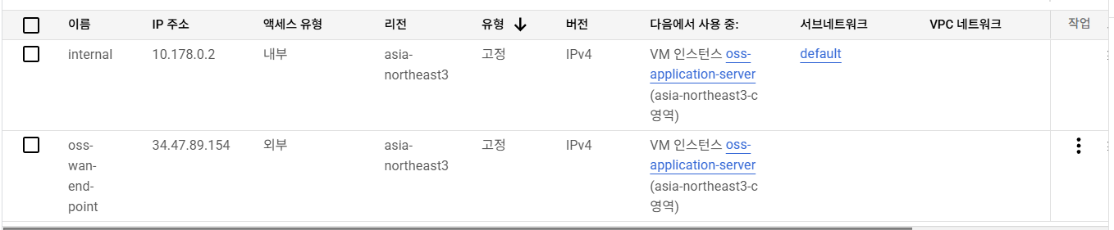
WAN (static) : 34.47.89.154 mapped domain (oss-emotion.nodove.com)
LAN (static) : 10.178.0.2
--
USER Info
User / password : OSS / doveross1234!

--
Opened ports
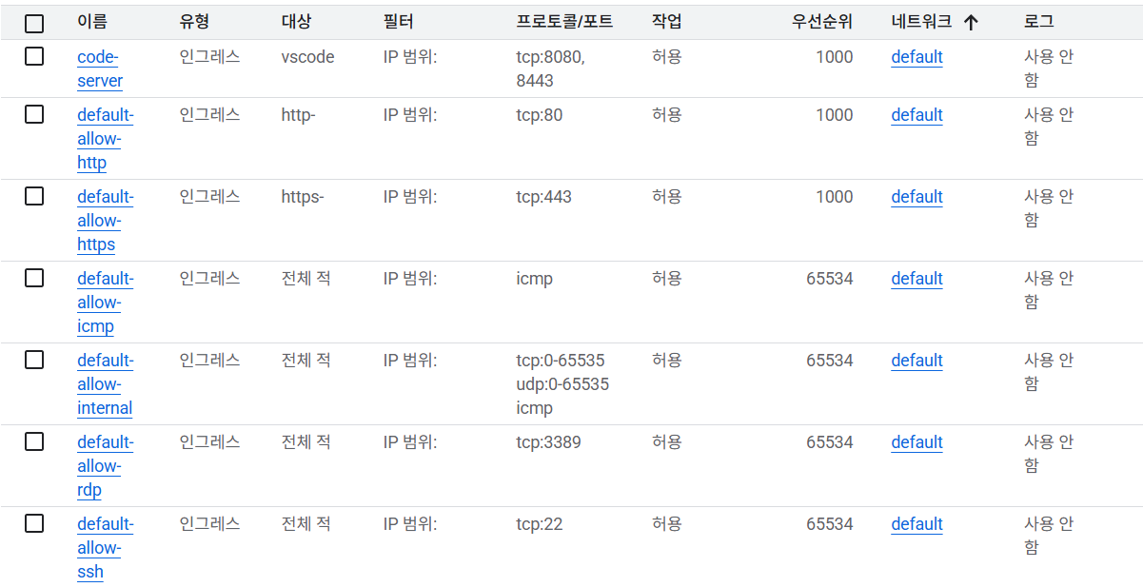
--

Develop SERVER – VSCODE server
Main :
https://oss-emotion.nodove.com/code/
if redirect to login page failed use :
https://oss-emotion.nodove.com/code/login
password :
YinGisNO0&$P5nGrG3x$0dRqoFb8Rn2fZk6aPy8M1n*PHGFF6OOa5HS0ftmlZ%e@Kxb^nKP2twRQR1eHY2Ggv64UbdoSPfa501Ge
--
Current nginx config setting
--
# certbot SSL/TLS url
location /.well-known/acme-challenge/ {
root /var/www/html;
}
# code server url
location = /code {
return 301 /code/;
}
# code-server url
location /code/ {
proxy_pass http://localhost:8080/;
proxy_set_header Host $host;
proxy_set_header X-Real-IP $remote_addr;
proxy_set_header X-Forwarded-For $proxy_add_x_forwarded_for;
proxy_set_header X-Forwarded-Proto $scheme;
proxy_set_header Upgrade $http_upgrade;
proxy_set_header Connection upgrade;
proxy_set_header Accept-Encoding gzip;
}
--
25/04/22 on running services

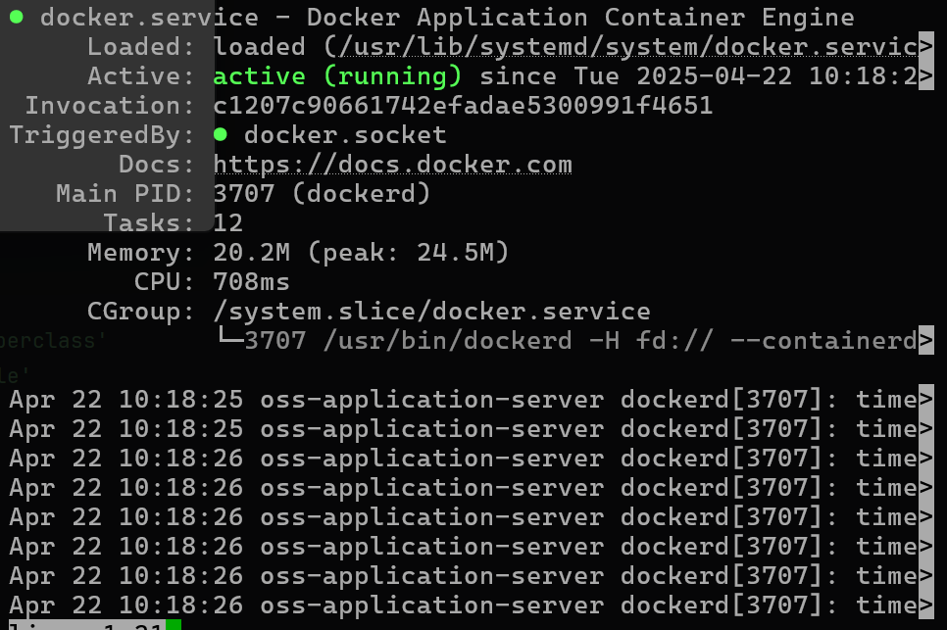
Docker

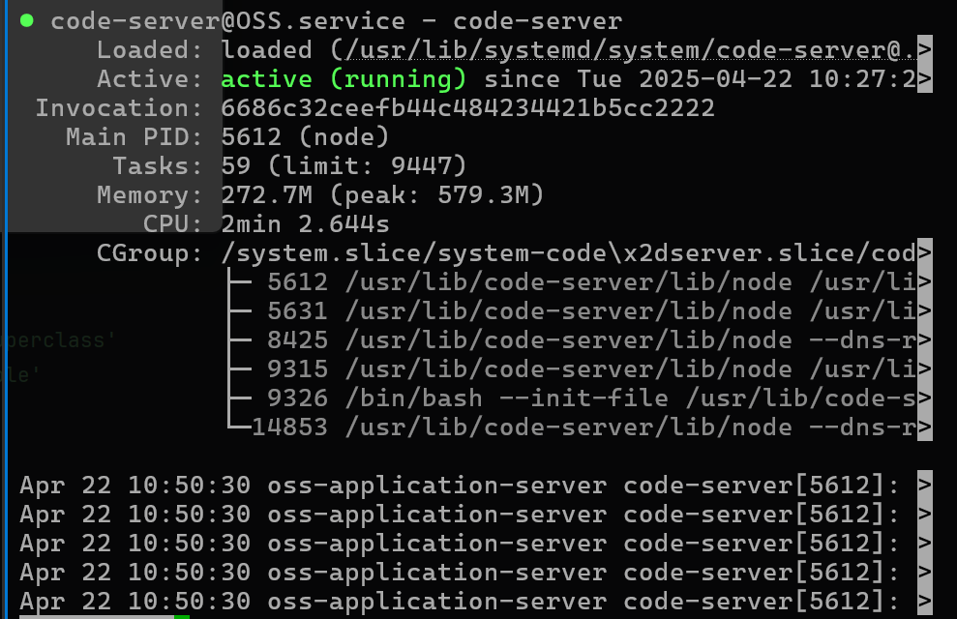
Code-serer@OSS

